US Together Refugee Integration Conference Registration Form:

Refugee integration is a complex and gradual process with legal, economic, social and cultural dimensions. US Together was founded in Columbus, with the purpose to assists refugees and immigrants escaping persecution, violence, tyranny, and extreme poverty. We facilitate their resettlement, provide social/economic integration, and help them build vibrant communities.

US Together, Inc. in partnership with OSU Wexner Medical Center invites you to join us for the 2018 Refugee Integration Conference: Overcoming Trauma to Integration, on October 30th and 31st, 2018. The conference will be held on OSU’s campus at the Biomedical Research Tower 460 W. 12th Ave., Columbus, Ohio. The cost to attend is $60 either day one or day two and $100 for both days, and CE Credits are available for nurses and social workers. Invoicing is available and separate per request. Community organizations are encouraged to table and display their information. Please contact Christine Garcia, MS, Director-Columbus Office with any inquiries at cgarcia@ustogether.us or (614) 437-9941 x 3221.

As one of the highest ranked hospitals in the country, Ohio State Wexner Medical Center is dedicated to improving lives and transforming traditional healthcare. OSU promotes health and wellness in all capacities while offering a wide range of opportunities for patients, students, and faculty. With diversity as one of their core values, OSU Wexner Medical Center is proud to provide a space for community members to foster inclusion.

Our conference will enable community members to discuss ways in which collectively we can provide trauma relief and encourage refugee civic participation.

- Day 1 focuses on overcoming trauma and the implications on delivery of healthcare along with discussions concentrating on political advocacy and power-mapping the electorate.
- Day 2 facilitates connections to statewide efforts underway to integrate the New American talent pool into our workforce.

The state of Ohio is home to the highest percentage of high skilled immigrants in the country, yet an estimated 30% are underemployed or unemployed. Local and national experts will present on best practices to serve this growing community of Ohioans; from the State of Ohio Office of Opportunities for New Americans and the National Skills Coalition, to the Ohio Welcoming Initiatives Network (OWIN) and others. Registration is available here: https://www.eventbrite.com/e/us-together-refugee-integration-conference-tickets-49913027208

Parking is available at:

12th Avenue Garage: 340 West 12th Avenue, Columbus, OH 43210
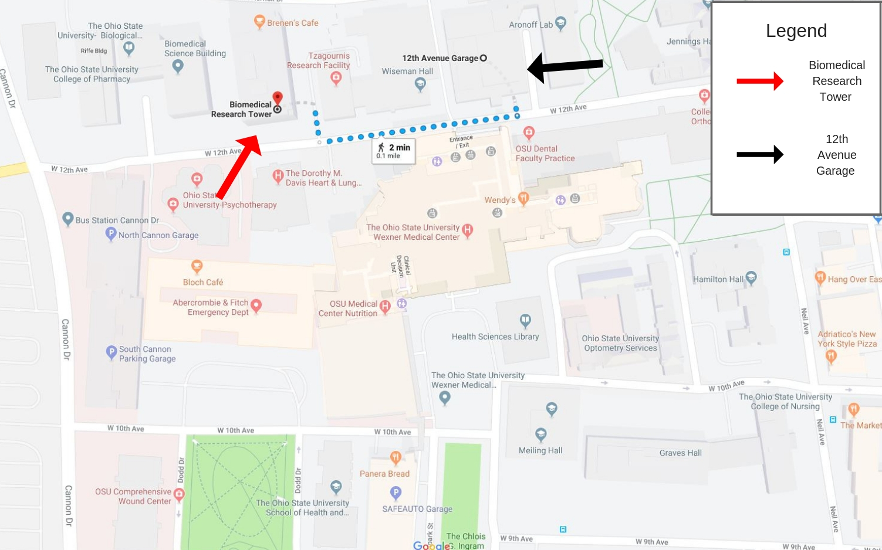

SAFEAUTO Garage: 1585 Westpark Street, Columbus OH 43210
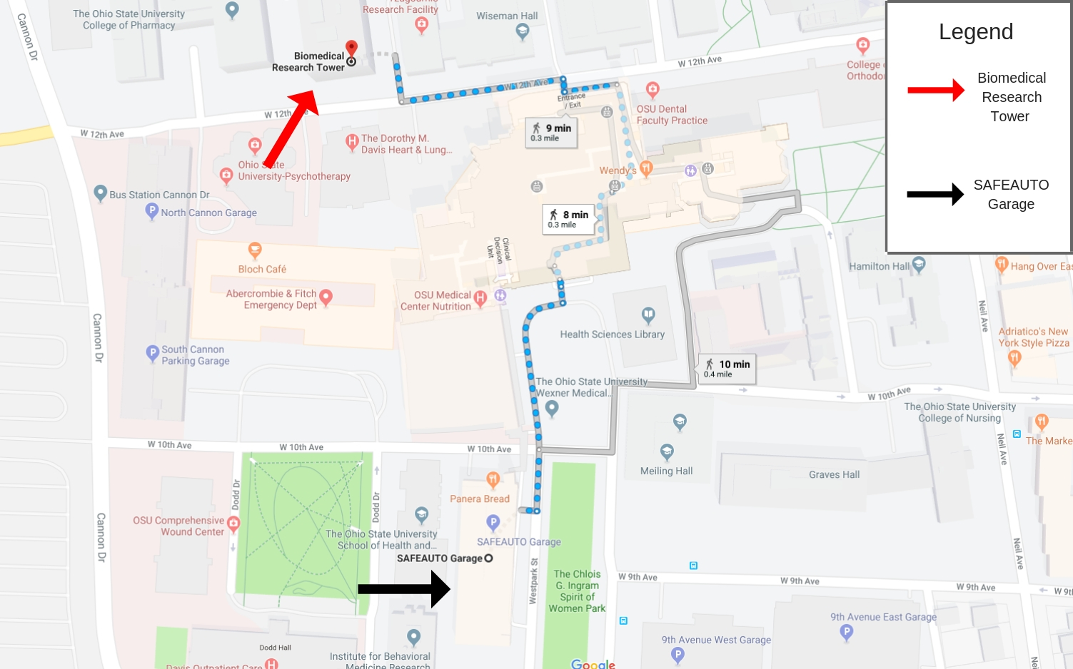

Parking day-passes cost approximately $12.00.

US Together has blocked rooms at discounted rates at two hotels under the name “US Together Conference:”

- Holiday Inn Express Suites Hotel at the Ohio State University:
3045 Olentangy River Rd, Columbus, OH 43202
(614) 447-1212

- Farfield Inn & Suites:
3031 Olentangy River Rd. Columbus, Ohio 43202
(614) 267-1111

Conference refunds are available up to 24-hours in advance. Please contact Christine Garcia, MS, Director-Columbus Office with any questions at cgarcia@ustogether.us or (614) 437-9941 x 3221.

